There is this sickness called the H3N2 flu that is infecting people. The purpose of this lab is to develop a simulation for The European Centre for Disease Prevention and Control (ECDC) regarding the how the death toll of a population will vary over time when given a number of healthy, sick, free riding people and number of vaccines at a given time. I will be testing 4 different scenarios which will be talked about in the results section.

To create this program, I first started with creating a separate file for a continuous model, and a separate file for a discrete model. The continuous model sets up the differential equations for the five different reactions. Then I set up a Jacobian model and solved the ODEs with the given timespan. The discrete model refers to the Gillespie model. Here the reaction rates are added together, the probability of the reactions are determined and then the cumulative sum of that vector (called “csp”) is determined. Afterwards, a random probability value between 0 and 1 is generated and compared against the values in csp vector. Based on this value, the time step is determined and how the variables change is also determined. In the end, the two models were combined into one program.

There were 4 different scenarios being tested and analyzed with this model; all figures being referred to are in the “Attachments” section. For scenario 1, initially there were 31,999 healthy people, one person sick person, 10000 doses of vaccine initially available, 15,000 additional doses of vaccine available on day 20, and 9600 free riders (Figure 1); at the end, there were about 2215 people who died. For scenario 2, the same scenario from scenario 1 was used, but the additional vaccines were added at 30 days (Figure 2) instead of 20. The graph showed that about 2937 people died. For scenario 3, the same scenario from scenario 1 was used, but the additional vaccines were added at 40 days (Figure 3) instead of 20. The graph showed that about 2991 people died. As shown in the Figures 1-3, it seems to show that as you increase the tAdd, then the number of dead of people seem to increase as well. However, the gap between 20 and 30 days seem to be so much larger than the gap between 30 and 40 days. For scenario 4 (figure 4), there are 9600 free riders and 50,000 doses of vaccine initially; this scenario showed that at the end of the time span, about 565 people were dead. Since the number of the vaccines was very high, it makes sense to say that there would be a lower death population.

In conclusion, based on the program, the general trend of the peoples’ death start off low and increase over time. The amount of dead people seems to be mostly affected by the number of initial healthy, freeloaders, sick, immune, dead people, number of vaccines available and when those vaccines are given. Overall, the ECDC can use this program to create a variety of combinations to determine how the population will change over time.

**ATTACHMENTS**

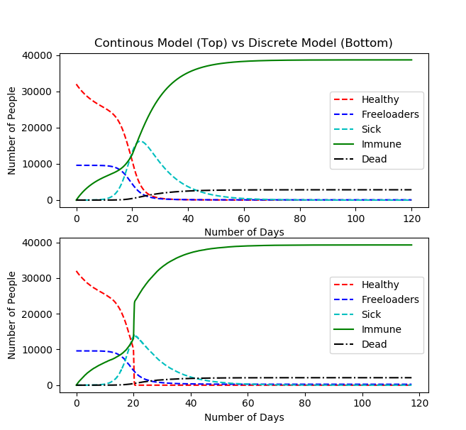

Figure 1: 20 Days

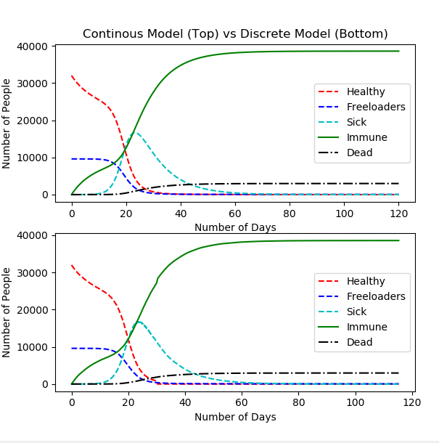

Figure 2: 30 Days

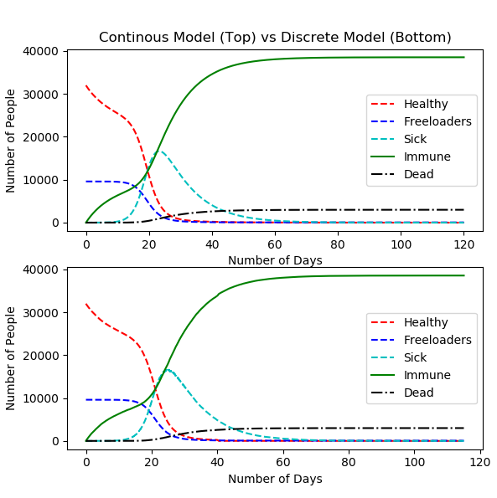

Figure 3: 40 Days

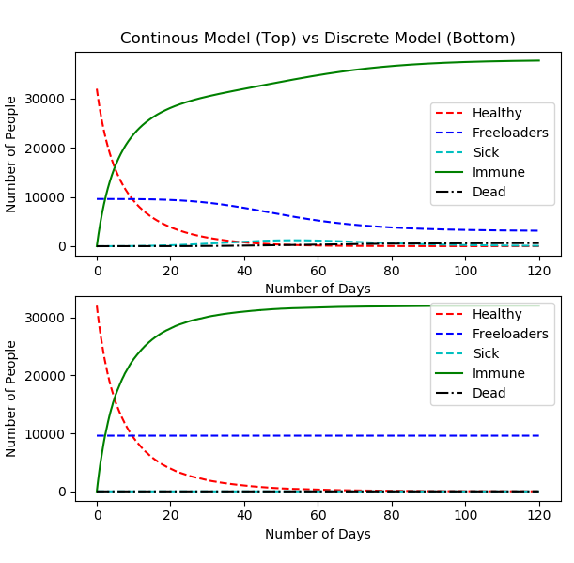

Figure 4: 50000 Vaccines Initially